

**Press Release**

**Subject: IIFCL Celebrates 20th Foundation Day with National Summit on India's Infrastructure Future**

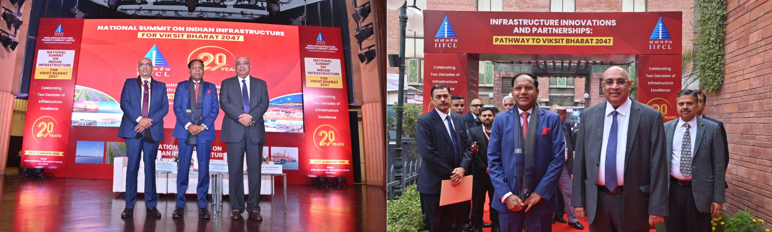

**New Delhi, January 06, 2025** – The India Infrastructure Finance Company Ltd. (IIFCL) commemorated 20 years of its commitment to infrastructure development by hosting the **National Summit on Indian Infrastructure for Viksit Bharat 2047** at the Stein Auditorium, India Habitat Centre. The summit convened prominent leaders, policymakers, and industry experts to chart a roadmap for India's infrastructure development, envisioning its transformation into a developed nation by 2047.

**Emphasizing the critical role infrastructure plays in driving economic transformation, Shri M. Nagaraju, Secretary, Department of Financial Services, said,** *"India's infrastructure journey is a testament to resilience and vision, and IIFCL has been at the heart of this transformation for 19 remarkable years. I congratulate the leadership at IIFCL for their exceptional contributions to funding India's growth story. As a key enabler in bridging public and private sector collaboration, IIFCL has demonstrated leadership in project finance, innovative solutions, and sustainability-driven growth. The Department of Financial Services remains committed to supporting IIFCL's mission to build a robust infrastructure ecosystem, aligning with India's vision of becoming a developed nation by 2047."*

**Congratulating IIFCL on its Foundation Day, Shri M P Tangirala, Additional Secretary, Department of Financial Services, said,** *"As IIFCL celebrates its 20th Foundation Day, we honor two decades of remarkable contributions to India's infrastructure growth story. IIFCL’s innovative financing and unwavering dedication have turned visionary projects into reality, paving the way for a stronger and more connected India. As we set our sights on Viksit Bharat 2047, I congratulate the IIFCL team for their outstanding achievements and look forward to their continued leadership in shaping a future defined by sustainable development and economic resilience."*

**Dr. P. R. Jaishankar, Managing Director, IIFCL**, reflected on the organization’s two-decade journey, highlighting its cumulative sanctions of ₹3 lakh crore across over 800 infrastructure projects with a total project outlay exceeding ₹14 lakh crore, and disbursements of approximately ₹1.5 lakh crore. Reiterating IIFCL’s commitment to financing emerging sectors and promoting green initiatives, Dr. Jaishankar underlined the institution’s pivotal role in advancing India’s infrastructure ambitions.

**Speaking at the National Summit on Indian Infrastructure for Viksit Bharat@2047, organised on the occasion of IIFCL’s 20th Foundation Day, Dr. P.R. Jaishankar, Managing Director, IIFCL, said**, “As we celebrate IIFCL’s 20th foundation day, we take pride in our service to the nation by contributing to its infrastructure growth story. We have been able to reduce our NPAs from around 20% five years ago to below 1% currently. The quality of our assets rated ‘A and above’ has increased to 92%, thereby showcasing our commitment to growth with quality. Together, we look forward to a digitally-driven, sustainable future, shaping the next 20 years with innovation and resilience.”

**The summit featured two dynamic panel discussions** that provided valuable insights into the future of India’s infrastructure.

The summit reaffirmed IIFCL’s pivotal role in India’s infrastructure growth. By integrating sustainability into its financing strategies and innovating financial products, IIFCL continues to align its efforts with the nation’s vision for **Viksit Bharat 2047.**

**About IIFCL**

IIFCL is a wholly owned government financier that caters to the long-term financing needs of India’s infrastructure sector. It is amongst the most diversified public sector infrastructure lenders in terms of eligible infrastructure sub-sectors. It is also active in providing inputs and policy support in the infrastructure financing space to the Government through various forums, with an aim to promote and develop world-class sustainable infrastructure in India.